Cyber Security Essentials

Lab 6 – Packet builder, IP Spoofing and DOS/DDOS attacks

Task 1: Analyse pcap/pcapng file

Import pcap/pcapng file provided as part of lab 5 using Colasoft packet builder tool and show how to spoof IP address.





Task 2: DOS attack

Show how can you launch DOS attack using multiple packets at a time. Also create a TCP packet, spoof source IP and show how to launch DOS attack using only 1 packet. (Hint: you need to send 1 packet multiple times continuously).

DOS Attack

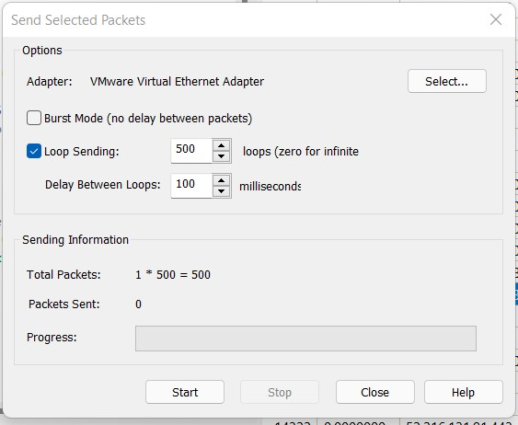

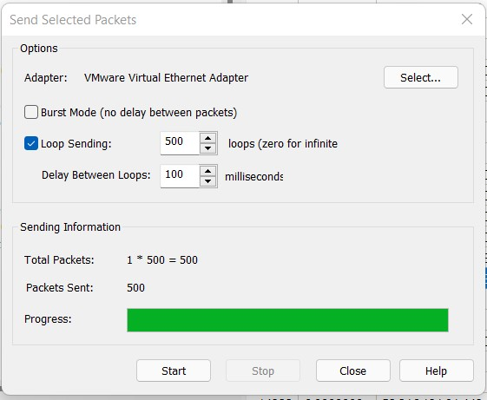

DDOS Attack

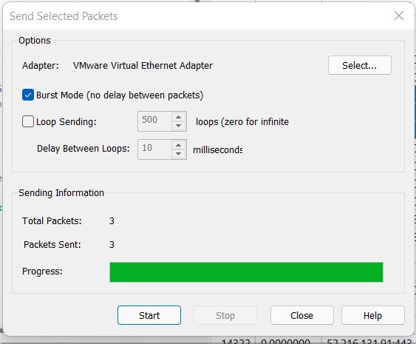

Task 3: Adding message to packet

Add message “Hi, My name is <Your Name>” to the packet you have created.

